Personal Research Project

Topic: Honeypot
Student Name: Rakibul Haque
Student Number: 4720342
Table of content

Introduction | 3
Methodology | 3
Findings and observations | 4
Challenges and Limitations | 6
Conclusion and Future Work | 6

Introduction
A honeypot is a tool used to identify, block, or investigate efforts to gain unauthorized access to data systems. It is basically an isolated, closely watched decoy system or resource, like a server, database, or application, that imitates a real target for cybercriminals. Honeypots are incredibly useful for detecting and examining harmful activity because they don't hold any important information or business-critical processes, thus any interaction with them is viewed as suspect.
Honeypots are primarily used for information collection and threat detection. They give security experts the opportunity to watch how attackers act, what resources they use, and what weaknesses they try to break. To improve security and understand new threats, this information is essential. As a kind of deception, honeypots are designed to distract attackers from real systems and give defenders time to respond. They are also useful settings for vulnerability research, enabling professionals to evaluate how threat develop and how systems react in a secure manner. Honeypots offer realistic yet constrained situations for evaluating incident reaction and detection skills during security and training exercises. They are sometimes used by law enforcement to track down cybercriminals and get forensic evidence. Honeypots can be low-interaction, replicating simple services, or high-interaction, closely resembling real systems to obtain more in-depth information, depending on their complexity.

I chose to understand the mechanism of honeypot as my personal research project. I started with TPot honeypot installation as it contains a lot of the honeypots.

Methodology
To install TPot, I spined up an instance on aws t3large as the requirement was 2 core CPU and 8GB of RAM. After installing honeypot, the default ssh port changes to 64295. The dashboard of the honey pot is served on port 64297. Here is the startpage of honeypot on figure 5.1.

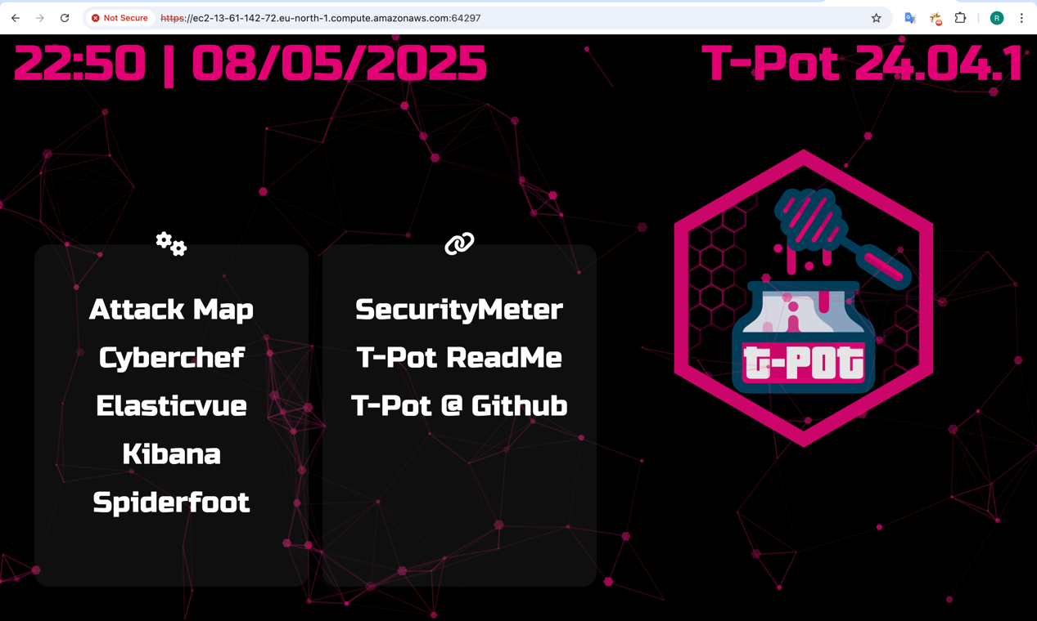
Figure 5.1
Here is kibana dashboard on figure 5.2.
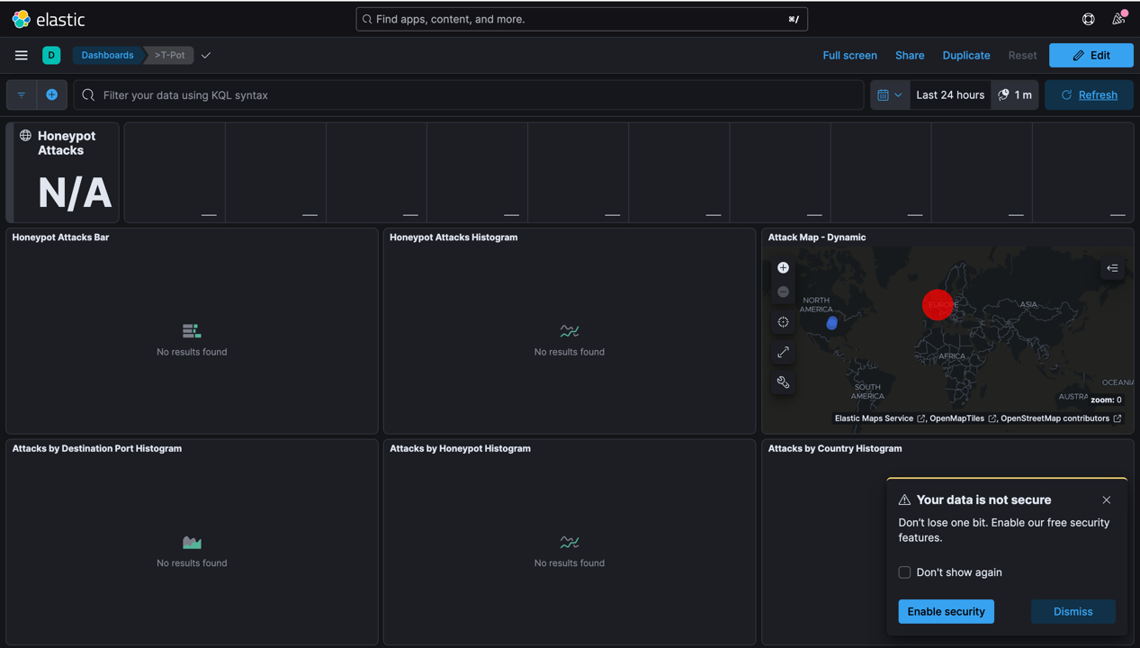
Figure 5.2
Findings and Observations
I tried to login with ssh on port 22 and here got alert on Kibana dashboard illustrated on figure 5.3.
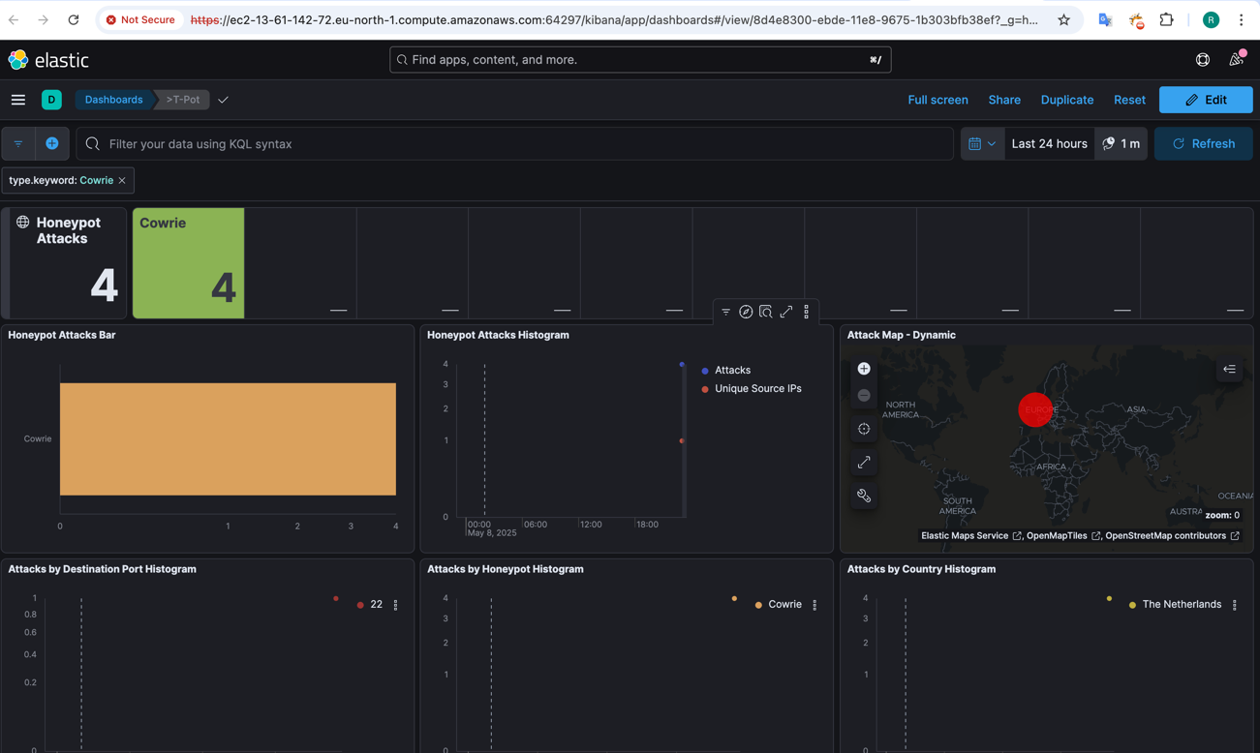
Figure 5.3
Here on figure 5.4, on attack map, it shows from where the attack derives.
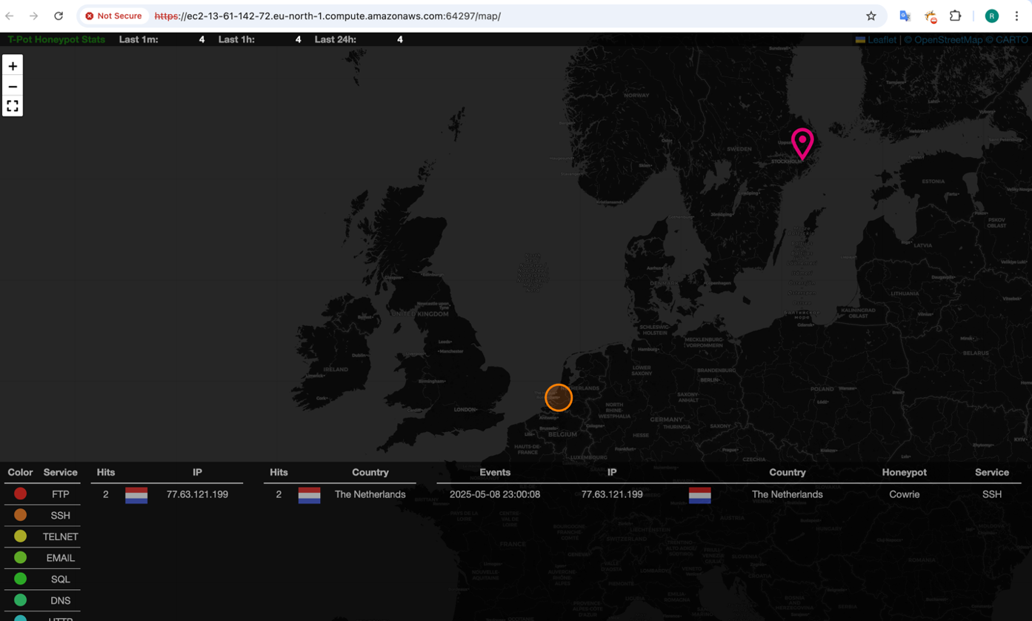
Figure 5.4
As my aws region was in Stockholm it marks it there and my location was in the Netherlands, and it marks it as well.

Understanding mechanism of all-in-one Honeypot T-Pot
TPot is developed and maintained by Telekom Security, a unit of Deutsche Telekom AG. TPot is designed for modularity, scalability, and ease of deployment. It uses Docker containers to isolate each honeypot service and employs the ELK stack (Elasticsearch, Logstash, Kibana) for real-time log aggregation and visualization. This makes it a powerful tool for both research and security operations centers (SOCs) aiming to detect and study attacker behavior in depth.

TPot runs various honeypots as Docker containers. Some commons are:
- Cowrie: Simulates SSH and Telnet services, logs commands and downloads.
- Dionaea: Collects malware through services like SMB, FTP, and HTTP.
- Conpot: Emulates industrial control systems (ICS).
- Heralding: Captures authentication attempts across multiple protocols.
- Honeytrap: Listens on TCP ports and responds dynamically to attacker probes
The logs from honeypot containers are collected by Filebeat and pushed to Logstash where logs are structured.
When the attacker scans the network, he finds the honeypots, mimicking real services. When the attacker tries to connect to those mimicking services, honeypots start logging the data like ip addresses, locations, timestamps, commands and many more if its set that way.
The attacker gets appropriate responses of their commands. But none of them gets executed on the host. The attacker can’t identify as it is in isolated environment, realistic responses and no privilege escalation command gets executed.
For instance, cowrie creates a fake shell using Python’s pty module, tricking the attacker into thinking they’re in a real terminal. To mock filesystem, it uses virtual file system that contains decoy files.
The data gets logged by the honeypot in json format mainly to get pursed by other applications for better visibility. These logs get saved in a database like Elasticsearch which is by default but for high-volume setups PostgreSQL server can be setup for extended research.

Challenges and Limitations
The challenge I faced throughout the research was the financial cost associated with using AWS. Since AWS services are billed based on instance size, data transfer, and storage, maintaining a continuously running t3 large instance with ELK stack components quickly became expensive. Due to these budget constraints, I was unable to run the honeypot over an extended period or at a larger scale, which limited the depth of the data collection and analysis I could perform.

Conclusion and Future Work
I gained valuable practical knowledge in cybersecurity through this research project, especially with using honeypots as deception and intelligence-gathering techniques. I was able to examine attack patterns, replicate real-world attacker scenarios, and assess how attackers engage with decoy systems by configuring T-Pot honeypot. This enhanced my knowledge of network security and brought to light the usefulness of threat intelligence and log analysis.
In the future to compare attack behaviors across platforms, I'm also interested in setting up honeypots in various environments, including on-premises or IoT networks. Future research may also look into automating incident response and integrating real-time alarm systems.

